**DIP Assignment**

1. A pair of 3×3 convolution kernels of Sobel operator (Gx and Gy) as shown in the below figures:

|  |  |  |
| --- | --- | --- |
| -1 | -1 | -1 |
| 0 | 0 | 0 |
| 1 | 0 | 1 |

|  |  |  |
| --- | --- | --- |
| -1 | 0 | 1 |
| -1 | 0 | 1 |
| -1 | 0 | 1 |

GX Gy

Perform the edge detected output image using Gx and Gy on the input image given below:

|  |  |  |
| --- | --- | --- |
| 12 | 10 | 13 |
| 14 | 12 | 13 |
| 15 | 14 | 11 |

2. Explain the Region-Based Approach for image segmentation with proper example

3. Compare and contrast global and local registration techniques in detail

4.Explain Dilation and Erosion techniques to perform the Morphological Operations with proper example

5. What is sharpening of an Image and how it is done. Explain Sharpening spatial filter for both 1st and 2nd order derivative filters.

6. Explain four primary steps involved in the image registration process

7. What is the significance of the structuring element in morphological operations

8. Explain the hit and miss transformation techniques with proper example

9. Describe three common techniques used for image segmentation. Explain how each technique works and provide a real-life application for each

10 Explain transform and similarity measures in details for registration with proper example

11. Explain how the mono-modal and multimodal image registration techniques performs image restoration .Show with proper example

12. A pair of 3×3 convolution kernels of Sobel operator (Gx and Gy) as shown in the below figures:

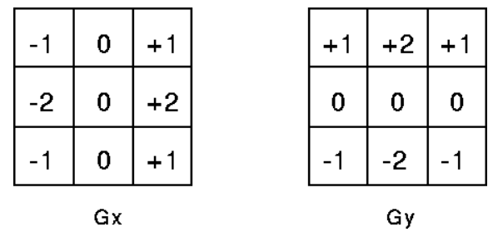

Perform the edge detected output image using Gx and Gy on the input image given below:

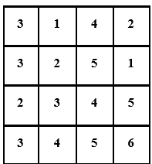

13. Explain Basic steps of Digital Image Processing in details.

14. Explain Image formation model with diagram.

15. is there any affect in size of an image by color quantisation.Justify